Date: 10.06.2025

Basics of Cloud Computing

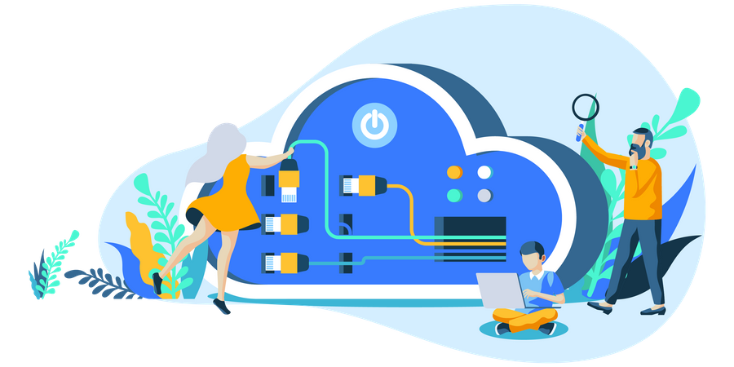

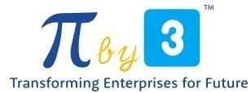

Copyright @ 2024 PibyThree.com All Rights Reserved

Contents

1. What is Cloud Computing? 2

2. What is a Cloud Service Provider (CSP)? 2

3. Landscape of CSPs 2

4. Common Cloud Services 2

5. Evolution of Cloud Computing 3

6. Evolution of Computing 3

7. Types of Cloud Computing 4

8. Cloud Deployment Models 4

# 1. What is Cloud Computing?

* Cloud Computing is the practice of using a network of remote servers hosted on the internet to store, manage, and process data, rather than a local server or a personal computer.
* Cloud Computing is the on-demand delivery of compute power, database storage, applications, and other IT resources.

# 2. What is a Cloud Service Provider (CSP)?

A CSP is a company which provides multiple cloud services. These cloud services:

* Can be chained together to create cloud architecture.
* Are accessible via a Single Unified API, eg. AWS API.
* Utilize metered billing based on usage, eg. Per second, per user.
* Have rich built-in monitoring, eg. AWS CloudTrail.
* Offers Infrastructure-as-a-Service (IaaS).
* Offers automation via Infrastructure-as-Code (IaC)

# 3. Landscape of CSPs

|  |  |
| --- | --- |
| **Tier 1 Top Tier** | Early to market, wide offerings, strong synergies between services, well recognized in the industry. |
| Amazon Web Services, Microsoft Azure, Google Cloud Platform, Alibaba Cloud |
| **Tier 2 Mid Tier** | Backed by well-known tech companies, slow to innovate and turned to specialization. |
| IBM Cloud, Oracle Cloud, Huawei Cloud, Tencent Cloud |
| **Tier 3**  **Light Tier** | Virtual Private Server (VPS) turned to offer core Iaas offering. Simple, cost-effective. |
| Vultr, Digital Ocean, Akamai Connected Cloud (Linode) |
| **Tier 4**  **Private Tier** | Infrastructure-as-a-Service software deployed to run in an organization’s own private data center. |
| OpenStack (Rackspace), Apache CloudStack, VMWare vSphere |

# 4. Common Cloud Services

The 4 core types of cloud services for IaaS:

1. **Compute** – Imagine having a virtual computer that can run applications, programs and code.
2. **Networking** – Imagine having a virtual network defining internet connections or network isolation between services or outbound to the internet.
3. **Storage** – Imagine having a virtual hard drive that can store files.
4. **Databases** – Imagine a virtual database for storing reporting data or a database for general purpose web-application..

# 5. Evolution of Cloud Computing

|  |  |
| --- | --- |
| **Dedicated Server** | * One physical machine dedicated to a single business * Runs a single web-app or site * Very expensive, high maintenance, high security |
| **Virtual Private Server** | * One physical machine dedicated to a single business * The physical machine is virtualized into sub-machines * Runs multiple web-apps or sites * Better utilization and isolation of resources |
| **Shared Hosting** | * One physical machine, shared by hundreds of businesses * Relies on most tenants under-utilizing their resources * Very cheap, limited functionality, poor isolation |
| **Cloud Hosting** | * Multiple physical machines that act as one system * The system is abstracted into multiple cloud services * Flexible, scalable, secure, cost-effective, high configurability |

# 6. Evolution of Computing

|  |  |
| --- | --- |
| **Dedicated** | **Virtual Machines** |
|  |  |
| **Containers** | **Functions** |
|  |  |

# 7. Types of Cloud Computing

|  |  |  |
| --- | --- | --- |
| **IaaS** | **Infrastructure as a Service** | **For Admins** |
| * The basic building blocks for Cloud IT. Provides access to networking features, computers, and data storage space. * *Don’t worry about IT staff, data centers, and hardware* * Amazon Web Services, Microsoft Azure, Oracle Cloud | | |
| **PaaS** | **Platform as a Service** | **For Developers** |
| * Focus on the deployment and management of your apps * *Don’t worry about provisioning, configuring, or understanding the hardware or OS* * AWS Elastic Beanstalk, Heroku, Google App Engine | | |
| **SaaS** | **Software as a Service** | **For Customers** |
| * A product that is run and managed by the service provider. * *Don’t worry about how the service is maintained. It just works and remains available.* * Salesforce, Google Workspace, Office 365 | | |

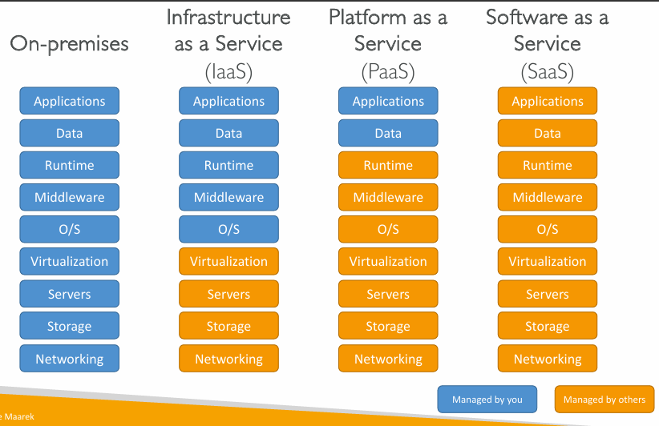

# 8. Cloud Deployment Models

|  |  |
| --- | --- |
| **Public Cloud** |  |
| Everything (the workload or project) is built on the CSP.  Also known as Cloud Native or Cloud First. |
| **Private Cloud** |  |
| Everything built on company data centers.  Also known as On-premise. |
| **Hybrid Cloud** |  |
| Using both On-premise and a Cloud Service Provider |